DATA TRANSFORMATION
Column profiling: (Quality check)
We look for null in GPA to determine whether the mean GPA will be skewed or not. We also look for empty or errors.
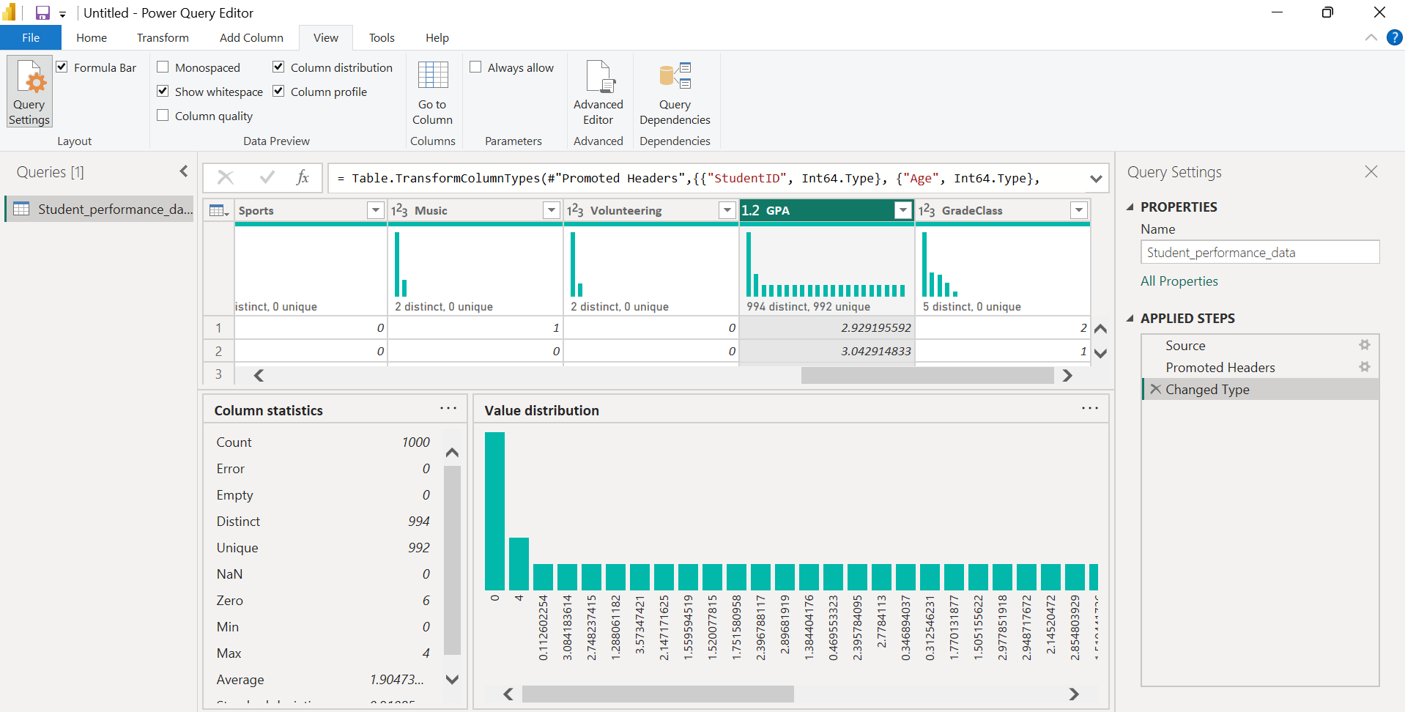
Data type alignment.
Ensure the columns are set to the right data type eg GPA is set to decimal
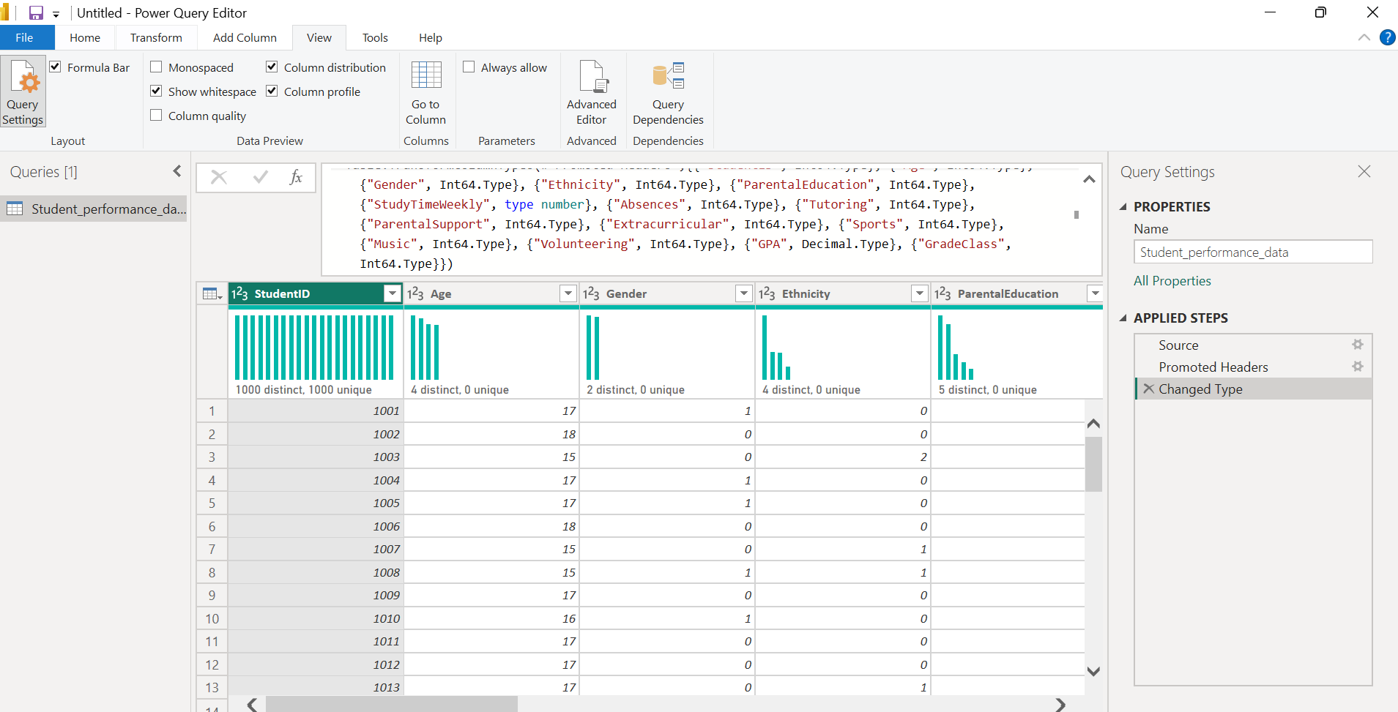

KPI Tracking & DAX(Data analysis expressions)
• Average GPA: Avg GPA = AVERAGE('StudentData'[GPA])
• Student Count: Total Students = COUNTROWS('StudentData')
• High Performer %: High Performer % = DIVIDE(CALCULATE(COUNTROWS('StudentData'), 'StudentData'[GPA] >= 3.5), [Total Students])
***(Those are examples but I only used the Average GPA and Average weekly study in )

Building the Interactive Dashboard
A User-Centered Design focuses on how a human interacts with the data.
• The Slicer: Place GradeClass in a Tile Slicer at the top.
• The Visual: A Scatter Plot of Study Weekly Time vs GPA.
• The "Why": By using the GradeClass slicer, a user can instantly see if "A" students have a different study-time distribution than "F" students. It turns a static chart into a tool for hypothesis testing (e.g., "Does more study always mean better grades for every class?").

Clustered Column Chart (GPA vs. Parental Support)
This is perfect for seeing how external factors influence grades.
- X-Axis: Parental Support (e.g., None, Low, Moderate, High).
- Y-Axis: Average GPA.
- Legend: Gender.
- Why use this: It allows the user to see two things at once: Does parental support help? And does it help one gender more than the other?
Ribbon Chart (Performance Over Age)
This is a specialized Power BI visual that is essentially a "fancy" bar chart that tracks rank changes.
- X-Axis: Age.
- Y-Axis: Average GPA.
- Legend: Tutoring (Yes/No).
- Why use this: The ribbons "flow" to show you which group is on top. If students who receive tutoring have a higher GPA at age 15 but drop below non-tutored students at age 18, the ribbon will physically cross over. It’s a powerful way to show shifts in performance metrics.

Not part of the work, just an addition.
Comparison Table: Which Chart for Which Data?
Data Goal | Recommended Visual | Key Benefit
Compare total numbers | Clustered Bar Chart | Easy to read labels on the Y-axis.
Show "Part-to-Whole" | 100% Stacked Bar | Normalizes data across groups of different sizes.
Show Trends/Rankings | Ribbon Chart | Visualizes which category is "winning" over a range.
Show Correlations | Scatter Plot | Best for finding the "Why" (e.g., Study Time vs GPA).

